**AI-Statistical Machine Learning Approaches to Liver Disease Prediction**

**Team ID: PNT2022TIMD48272**

**Faculty Mentor:** **Team Leader :** G.Lydia

D.Pradhiba **Team Member :** R.Priya

**Team Member :** U. Lavanya sri

**Team Member :** G. Nagalakshmi

**Software Installations**

In order to develop this project we need to install following software/packages

**Anaconda Navigator:**

Anaconda Navigator is a free and open-source distribution of the Python and R

programming languages for data science and machine learning related applications.

It can be installed on Windows, Linux, and macOS.Conda is an open-source,

cross-platform, package management system. Anaconda comes with so very nice

tools like JupyterLab, Jupyter Notebook, QtConsole, Spyder, Glueviz, Orange,

Rstudio, Visual Studio Code. For this project, we will be using Jupyter notebook

and Spyder.

# Installing on Windows:

1. [Download the Anaconda installer](https://www.anaconda.com/).
2. Go to your Downloads folder and double-click the installer to launch. To

prevent permission errors, do not launch the installer from the [Favorites folder](https://docs.anaconda.com/anaconda/user-guide/troubleshooting/#distro-troubleshooting-favorites-folder).

1. Click **Next**.
2. Read the licensing terms and click **I Agree**.
3. It is recommended that you install for **Just Me**, which will install Anaconda

Distribution to just the current user account. Only select an install for **All**

**Users** if you need to install for all users’ accounts on the computer (which

Requires Windows Administrator privileges).

1. Click **Next**.

7. Select a destination folder to install Anaconda and click **Next**. Install

Anaconda to a directory path that does not contain spaces or unicode

characters. For more information on destination folders, see the [FAQ](https://docs.anaconda.com/anaconda/user-guide/faq/#distribution-faq-windows-folder).

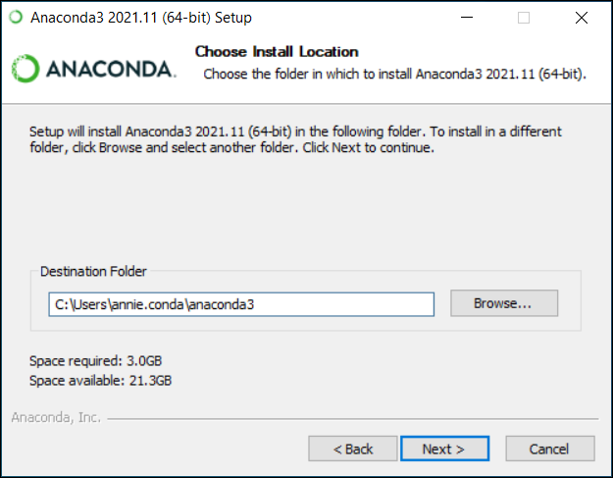

8. Choose whether to add Anaconda to your PATH environment variable or

register Anaconda as your default Python. We **don’t recommend** adding

Anaconda to your PATH environment variable, since this can interfere with

other software. Unless you plan on installing and running multiple

versions of Anaconda or multiple versions of Python, accept the default and

leave this box checked. Instead, use Anaconda software by opening

Anaconda Navigator or the Anaconda Prompt from the Start Menu.

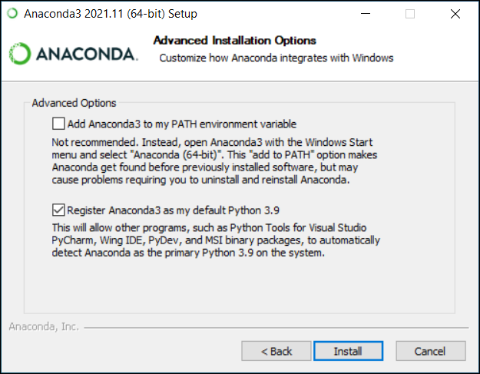

9. Click **Install**. If you want to watch the packages Anaconda is installing, click

Show Details.

10. Click **Next**.

11. Optional: To install Data spell for Anaconda, click

<https://www.anaconda.com/dataspell>. Or to continue without Dataspell,

click **Next**.

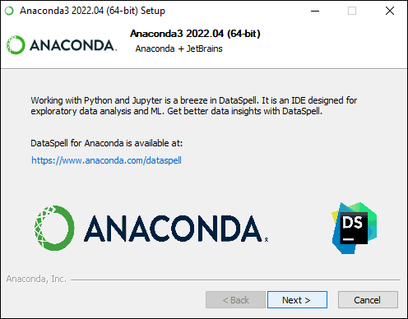

12. After a successful installation you will see the “Thanks for installing

Anaconda” dialog box:

13. If you wish to read more about Anaconda.org and how to get started with

Anaconda, check the boxes “Anaconda Distribution Tutorial” and “Learn

more about Anaconda”. Click the **Finish** button.

